QUEENS FALCONS FOOTBALL 2004

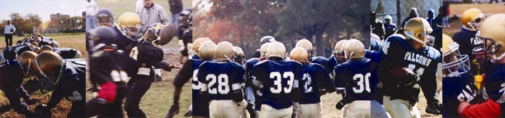

Registration for the 2004 Tackle Football Season for youth ages 7 -19 is NOW!
Date: Saturday May, 22, 2004
Time: 10AM – Noon
Location: The Lost Battalion Hall, 93-29 Queens Blvd, Rego Park, NY 11374

Divisions Ages Maximum Weight Spring Practice Date
Peanut 7-8 90 lbs Sunday
Jr. Pee Wee 9-10 110 lbs Sunday
Pee Wee 11-12 135 lbs Sunday
Midgets 13-14 155 lbs Saturday
Intermediates 15-16 185 lbs Saturday
Juniors 17-19 Unlimited Saturday

A parent and or guardian must accompany the player to registration to be weighed in, sign a permission form, bring a copy of the player’s birth certificate and their most recent report card. We provide all practice and game equipment, including game uniform (jersey, pants and socks). NEW: Practice shorts, T-shirt and hat. The total cost is only $225. Cash, personal check or Money Orders should be made payable to the Forest Hills Football League. Player must provide and wear mouth piece and athletic supporter; cleats must be rubber and are recommended.

Practices begin June 1st, 6pm – 9pm, and continue every Wed and Friday in June.

Location: Juniper Valley Park 3 blocks West of Woodhaven Blvd & 63rd Ave
1 mile from the Queens Mall, Q38, Q29
Middle Village, Queens 3 blocks east of 69th St. & Juniper Blvd South
Brennan Field 1 block off Eliot Ave & Juniper Blvd North

PLAY LIKE A CHAMPION

If you have any questions, please go to our website www.queensfalcons.net or send me an email at greg.hoffman@queensfalcons.net

